

Eurocomp reciprocating compressors

Modern compressed air classics for the workshop

Kaeser’s “Eurocomp” (EPC) compressors provide highly cost-effective and efficient compressed air solutions for users who require only small delivery volumes, or who do not require a constant compressed air supply. These compact, stationary reciprocating compressors are also the perfect choice for workshops and industrial environments where space is at a premium.

Many people believe that lower compressed air demand means high cost per cubic metre, but that doesn't have to be the case. What's required is a compressed air system that meets the exact needs of the compressed air application. In workshops for example, there are various tasks for which a stationary compressed air supply system may be appropriate, but where a constant supply of compressed air, or even around-the-clock compressed air availability, are not required. This is where the 'Eurocomp' (EPC) series of classic reciprocating compressors from Kaeser Kompressoren truly stands out, as the wide range of available models ensures that even the most specific workshop needs can be met.

Every EPC compressor is equipped with a high quality, German-made compressor block from Kaeser, whilst premium grade materials and meticulous assembly guarantee outstanding performance and long service life. Furthermore, the efficient aluminium ring-profile aftercooler keeps compressed air temperatures to a minimum and its special design provides effective protection against unintentional contact. The motor and compressor block are directly coupled in order to achieve optimum efficiency and to keep operating costs as low as possible.

Versions are also optionally available with additional soundproofing for workshops where the compressor needs to be installed directly within the working environment. This reduces the already low sound levels achieved through low speed operation by a further 10 dB (A). The enclosure can also be retrofitted as required.

Double vibration damping between the compressor unit and air receiver, as well as between the air receiver and the floor, ensures that these versatile systems operate seamlessly within the work environment.

The vertical air receiver models are especially suited for use in workshops where space is at a premium. They have displacements of up to 1000 l/min, yet have a compact footprint of less than 1 m². The EPC series as a whole covers a displacement range from 150 to 1500 l/min at maximum working pressures of 10 bar, or up to 1000 l/min at 15 bar. According to requirement, models are available with 90-, 250-, 350- or 500-litre capacity air receivers.

The 'Eurocomp' series therefore provides everything you need for an energy-saving, cost-effective and environmentally friendly compressed air supply - they even come ready equipped for immediate operation.

Datei: Eurocomp-de
2.860 Zeichen − Abdruck frei, Beleg erbeten

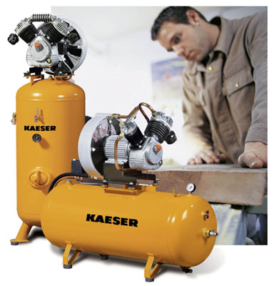
“Eurocomp” reciprocating compressors provide a cost-effective solution for workshops requiring smaller volumes of quality compressed air.

