Mobilair M120
Built tough for extreme conditions
Whether for quarrying, mining or blasting applications, the M120 portable compressor is an excellent choice when operating in extreme performance and ambient conditions. Developed particularly with harsh environments in mind, this rugged machine delivers up to 400 cfm (11.3 m³/min) of compressed air. It can run seamlessly on high-sulphur diesel, and continues operating in the green zone even when ambient temperatures reach +50 °C.
The enclosure on the M120 conceals beneath it a low-emissions Cummins engine certified to the previous European Emissions Stage IIIA / Tier 3. This means that it may not be operated in the EU, USA or Canada; however, it is the ideal choice for other parts of the world where there is a high sulphur content in the fuel.
For applications such as those typically found in refineries, the M120 is equipped with a certified spark arrester and an automatic engine shut-off valve. A highlight of the easy-to-access interior is an innovative new oil separator design featuring two spin-on cartridges, which ensure a low residual oil content for the compressed air whilst at the same time greatly simplifying maintenance work.
Thanks to the innovative pV Control, the operator has only to select between two pressure stages; one to a max. of 10.3 bar (125 psi) and the other up to 14 bar (200 psi). This feature adjusts the maximum possible flow rate (V) to match the pressure (p) set at the controller.
Operation via the renowned Sigma Control Smart controller is child’s play. Display information includes, amongst other things, the required date of next maintenance. Start-up is at the push of a button; the machine then runs unloaded, thereby ensuring safe cold starts in all conditions. The display indicates the end of the warm-up phase, after which the machine can be switched to load in order to begin generating compressed air. Setting the pressure is also straightforward and intuitive.
Depending on the desired application, the system can be equipped with an aftercooler or a microfilter combination for technically oil-free compressed air. Rather than being discharged from the machine, accumulating condensate is evaporated by the hot exhaust gases from the engine, ensuring eco-friendly operation.
The M120 is available as a construction site chassis equipped with parking brake, a road-going chassis fitted with a run-on brake and lights for towing on the public highway, or as a stationary version mounted on skids. Integrated forklift guides and lifting eyes, which can be reached via climbing aids, are fitted as standard.

Approved for publication, copy appreciated

Image:

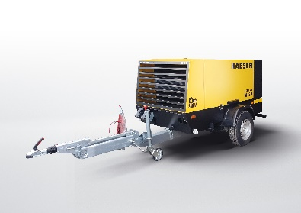

The M120 is a high-performance portable compressor that can run on fuel with a high sulphur content.

