High-efficiency
Compressed air for jet milling applications
When it comes to generating compressed air, operators of jet milling equipment for the production of very fine powders can achieve significant energy cost savings through the skilful use of heat recovery. It is for this very reason that Kaeser has recently expanded the options palette for its range of oil-free compression rotary screw compressors from the CSG, DSG and FSG series.
Aside from steam, jet mills are most commonly operated using nitrogen or compressed air. In the case of the latter, heat energy can be recovered from the compressed air inside the jet nozzles and subsequently reused for the milling process. Exhaust heat arises as a by-product of compressed air generation, which essentially makes it a cost-free source of energy.
With the specific needs of jet milling applications in mind, Kaeser has now extended the options palette available for its two-stage, oil-free compression rotary screw compressors to include such features as compressed air discharge temperature control. Operating via flexible, controlled adjustments to the intercooler, this option can lead to a clear reduction in specific energy consumption per tonne of the final product, depending on the type of material being processed.
Kaeser offers the option of compressed air discharge temperature control on compressors from the CSG, DSG and FSG model range, featuring a power range from 37 - 355 kW and pressure from 4 - 11 bar. Both air-cooled and water-cooled versions are available.
Furthermore, Kaeser also offers compressors specially adapted for operation with nitrogen, in which the compressor can be individually configured to the specific nitrogen circuit.

Free for publication, copy appreciated

Images:
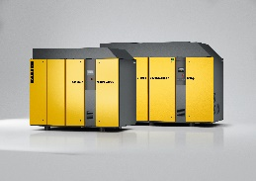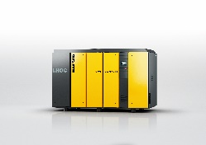
Oil-free compression rotary screw compressors from the CSG, DSG and FSG series are capable of supplying process heat as well as compressed air, making them ideal for operation in jet milling applications.

