CSD/CSDX
More efficient than ever before
Rotary screw compressors are the dependable backbone of an industrial compressed air supply. With a multitude of features, the innovative CSD/CSDX range from Kaeser Kompressoren fulfils this role more efficiently, dependably and economically than ever before, whilst at the same time reducing your company’s CO_{²} footprint.
The most important highlight of these compressors is their low energy consumption, which has been achieved via a number of innovative measures. The CSD/CSDX model series impresses with drives of the best possible efficiency class, whether speed-controlled (IE5) or fixed-speed (IE4). The centrepiece of all compressors in this series is the rotary screw airend with flow-optimised “Sigma Profile” rotors, specially developed for this performance range. These and numerous other improvements, such as speed-controlled fan motors, have enabled the energy efficiency of the compressor system to be enhanced, which has significantly reduced energy consumption, resulting in reduced energy costs and an improved CO_{²} footprint. What’s more, the new design has led to improved accessibility to all relevant components and therefore increased maintenance-friendliness.
Featuring motors with power from 45 to 110 kW, models from this series can cover delivery volumes from 8.4 to 19.4 m³/min and are designed for pressures up to 15 bar. Particularly at low pressures, even higher delivery volumes can be achieved.
The environmentally friendly system design even extends to the fluid filter elements: they are metal-free and after use can simply be thermally disposed of without need of further treatment.
In addition to the standard versions, versions with an add-on refrigeration dryer module are available, which permit both compressed air generation and drying in a comparatively small space. The refrigeration dryer is dimensioned for high ambient temperatures and operates with very little pressure loss. In comparison to the previous version, energy consumption has been reduced significantly, whilst the required refrigerant charge is also around 25 percent lower. The dryer is accommodated in a separate housing and is therefore not negatively influenced thermally by the exhaust air from the compressor.
The CSD and CSDX are both available with variable speed control; as with the standard systems, these versions are designed for optimised cost-efficiency, operational reliability and maintenance-friendliness.
All Kaeser rotary screw compressors impress when it comes to the question of sustainability. Not only do they operate extremely economically, but they are produced in Germany to the strictest quality standards and requirements. Exceptional durability means they can serve a company for many decades to come. Should it ever become necessary to replace them, many of the components used in their manufacture are recyclable. When it comes to your compressed air supply, Kaeser also represents a plus point with regard to nature and the environment.

Free for publication, Copy appreciated

Images

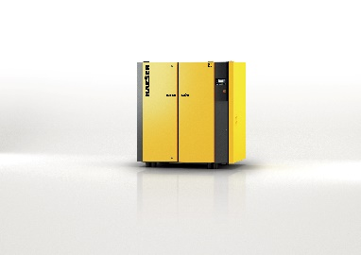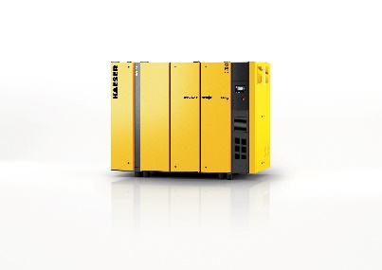

The CSD and CSDX impress with high efficiency, cost savings and sustainability.

