Mobilair M450
The heavy-duty performer
The heavy-duty M450 portable compressor was specially-developed to deliver unwavering performance under extreme environmental conditions. With a maximum available flow rate of 48.1 m³/min (1700 cfm) and adjustable pressure between 6 and 14 bar, it also provides exceptional power and versatility. The largest portable compressor in the Mobilair series therefore assures a dependable supply of quality compressed air no matter whether in the desert or in the cold.

This versatile portable compressor is ideal for applications such as drilling, quarrying and blasting work, or can serve as an energy source for mining and tunnel construction sites.

Beneath the hood is an electronically-controlled MTU engine with an output of 360 kW, meaning that the M450 fulfills 'Stage IIIA' emission or 'Tier 3' regulations and can handle fuel containing sulphur. Moreover, the combination of a premium efficiency airend featuring flow-optimised Sigma Profile rotors and the energy-saving fan installed as standard ensures exceptionally economical diesel consumption.

Thanks to the innovative pV control, the operator only has to choose between two pressure levels. The set pressure 'p' directly influences the maximum flow rate 'V'. One and the same system can therefore deliver pressures between 6 and 14 bar.
For applications requiring 7 bar, a version delivering up to 8.6 bar is available, for example, with a powerful flow rate of 48.1 m³/min (1700 cfm).

Operation could not be simpler, since the the M450 uses the proven Sigma Control Smart controller, which also indicates when the next scheduled maintenance is due. Following the push-button start, the system runs in unloaded state to ensure a safe cold start in all situations. The display shows the end of the warm-up phase and the system can then be switched to load operation to generate compressed air. Pressure adjustment is also straightforward.

Depending on the application, the system can be equipped with a compressed air aftercooler, or with a microfilter combination for technically oil-free compressed air. With environmental protection in mind, accumulating condensate does not drip out of the system, but is evaporated via the hot exhaust gases.

The M450 is optionally available on a construction site chassis with a steering axle and parking brake, or as a stationary version with skids. The system is equipped as standard with an integrated forklift guide and lifting eyes for ease of transport, which can be safely accessed using climbing aids.

Released for publication, copy appreciated
Image:
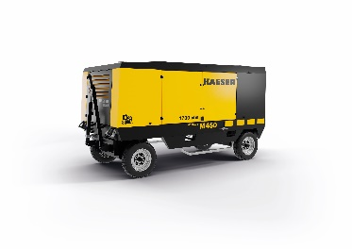
The new M450 from Kaeser is the compressed air giant for countries outside of Europe and North America. This versatile portable compressor provides a dependable supply of quality compressed air even under extreme environmental conditions.

