CBS Screw Blowers
Powerful Performance in a Compact Package
Screw blowers deliver the most efficient performance for the low-pressure range. And the CBS from Kaeser now brings all the advantages of screw blower technology to lower flow rate applications.
For municipal or industrial wastewater treatment plants requiring compressed air with differential pressures up to 1100 mbar, the CBS screw blower is the perfect solution – with power from 7.5 to 22 kW and flow rates from 2.3 to 12.2 m³/min. Thanks to its many advantages, the CBS also shines in applications such as production of aeration air in water treatment and for bioreactors, flotation and fluidisation. It’s up to 35 percent more efficient compared to conventional rotary blowers and even offers significant energy advantages in the two-digit range compared to other screw and turbo blowers on the market. One screw blower is so powerful that it efficiently covers the control range of two or three rotary blowers.
This impressive efficiency is achieved in part through the use of the highly successful Sigma Profile rotors known from the rotary screw compressor segment. Even at maximum speeds, these rotors ensure minimal transmission loss and lowest-possible energy costs.
The energy efficiency of the CBS, its low maintenance requirement and the ability to set up CBS units directly adjacent to one another make this series especially advantageous for continuous operation. They come equipped with integrated frequency converter or star-delta starter, as desired. The screw blowers are delivered as connection-ready machines (with power electronics and the Sigma Control 2 controller) that can be put into operation immediately, without additional effort.
Intelligent control
The Sigma Control 2 blower controller, which is also integrated, ensures comprehensive monitoring and straightforward connection of each individual machine to operational communication networks along the principles of Industrie 4.0. This smart controller also makes it possible to rapidly integrate the blowers into the Sigma Network, unlocking the advantages of the Sigma Air Manager 4.0 for use in low-pressure blower stations as well.

File: h-cbs-en
2.174 keystrokes − Approved for publication, copy appreciated
Images:
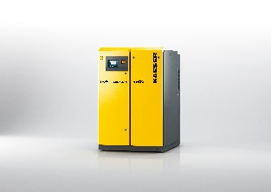
Rotary screw technology for blowers from Kaeser: the powerful CBS series delivers quiet operation and saves energy costs.

