“M 57utility”: No external power supply required
Hybrid technology is currently the talk of the town in the engineering industry. Kaeser Kompressoren however has come up with an altogether different hybrid solution to meet the needs of numerous specialised compressed air applications: The diesel powered stationary 'M 57utility' rotary screw compressor.
Innovative solutions are often the simplest, but you do have to come up with the ideas in the first place. This is as true today as it was when the wheel was first invented. The concept of the new 'M 57utility' compressor has much in common with that world-changing invention, at least to a certain extent: The unit combines the advantages of a modern stationary screw compressor with the location flexibility of a portable compressor – it is used like a stationary compressor, but is also mobile. This may sound like a contradiction in terms, but it really isn’t: As the “M 57utility” is powered by a diesel engine, there is no need for an external power supply. The system was therefore primarily developed to be installed as a stationary compressor on the flatbed of a truck. A fixed crane eye on the top of the unit’s housing makes loading easy, whilst forklift pockets in the closed environmentally-friendly base frame ensure safe, dependable maneuverability via fork-lift truck.
As one would expect from a system equipped with an advanced rotary screw compressor, the ‘M 57’ provides outstanding performance, energy efficiency and user-friendliness. With a drive power of 36 kW, the compressor has an effective free air delivery of 5.1 m³/min at 7 bar. The standard version is designed for operation in ambient temperatures from -10 to +50 °C, but a low temperature model is also available which can be used to ensure a dependable supply of quality compressed air at ambient temperatures down to -25 °C. At the heart of each unit is a durable rotary screw airend featuring the renowned ‘Sigma Profile’, which uses 15% less energy compared to conventional airend rotor designs. Furthermore, Kaeser’s highly efficient 1:1 drive design eliminates the transmission losses associated with gear or V-belt driven systems, as the airend is directly driven by a water-cooled, 4-cylinder Kubota diesel engine.
Amongst the 'M 57's' other distinct advantages are its compact design, exceptional power and energy efficiency. All maintenance access points are easily accessible once the applicable retaining pins have been removed from the load floor side and fuelling is carried out from the front face of the unit. This is where the control panel, maintenance connections and three compressed air connections - all protected by a metal cover – are also located.
Users will also appreciate a further feature of this new compressor: Both the standard and the low temperature versions are fitted with Kaeser’s Anti-Frost Control. This system is particularly useful at times of the year when ambient temperatures are lower, as it protects air tools against freezing and corrosion. Reliability is further enhanced by the fuel filter with water separator that are fitted as standard and the vertical discharge stainless steel exhaust pipe that also features a rain protection flap. Moreover, the wide range of available tool and accessories, such as screw-in machine feet, tool lubricators and compressed air after-coolers, also means that the system can be precisely tailored to suit the exact demands of the working environment. Built to Kaeser’s renowned high quality standards, the 'M 57utility' is designed to provide many years of dependable service.

3.598 Keystrokes − Free for publication, Copy appreciated

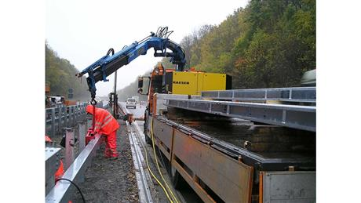

The compact 'M 57utility' combines the advantages of a modern stationary screw compressor with the location flexibility of a portable compressor. With a free air delivery of more than 5 m³ at 7 bar, this independent diesel-powered system requires no external power supply.

