Mobilair operating concept
On – Off! Done! Secure!
In moments of stress on the construction site, every control knob can be one too many. That’s why Kaeser portable compressors with capacities from 11 m³/min and up are designed with a stunningly simple operating concept – a rotary switch. Operation could literally not be more straightforward.
The new operating panel is fitted to Mobilair models M125, M171 and M255 with delivery volumes between 11 and 25 m³/min.
Start-up and shutdown of the electronically controlled engine with EU Stage V / US Tier 4 emissions is performed simply and conveniently via a rotary switch control. All that is required to switch the machine on is to turn the red rotary switch from the left position to the right; the controller is activated, the engine starts and warms up, and the compressor begins to deliver the required volume of compressed air.
Stopping the machine involves exactly the same procedure in reverse: the red rotary switch is turned back to its initial position on the left, the machine is vented and then switches off autonomously following the run-on phase. The shutdown procedure, including AdBlue recirculation, takes place automatically in the background.
Of course, if desired the compressor can also be switched manually to unloaded run via an intermediate setting; in this case the engine will remain running, but the compressor does not deliver compressed air.
Information regarding the operating status of the machine is available intuitively via a 7-inch touchscreen display. In the main menu, diesel and AdBlue fill levels can be read off from a distance.
Simply swiping the display brings up the pressure setting menu. By touching the plus sign icon, which is possible even when wearing bulky work gloves, the working pressure can be increased, and decreased again using the minus sign. Pressure can be adjusted precisely in steps of 0.1 bar to meet the needs of the relevant application.
When the pressure setting is adjusted, pV Control operates in the background. Here, the set pressure (p) influences the max. available flow rate (V), which allows the same machine to operate anywhere between 6 and 14 bar.
This provides future-proof reserves for a multitude of different applications, or can compensate for pressure losses when working daily with longer hose lines.
On the outside of the unit, the controller is protected from malicious damage by a lockable cover flap.

Approved for publication, copy appreciated

Image:

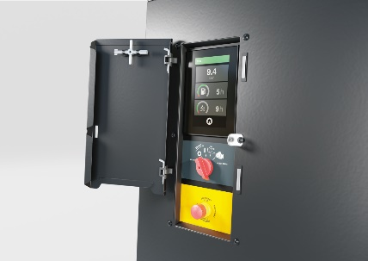

On – Off – Done. Thanks to a new operating concept featuring a rotary switch, operation of Mobilair portable compressors is easier and safer than ever.

