Economical Production of Compressed Air up to 45 bar
New boosters now available in the lower performance range
The use of boosters makes sense in applications that need process air at a higher pressure than normal control and works air, the maximum pressure of around 40 bar that boosters normally achieve is insufficient for a lot of modern applications such as the production of PET containers. To meet such demands, Kaeser has developed the N-series of boosters that can reliably and economically raise the pressure of standard works air to 45 bar.

This finely graded series covers a power range of up to 18.5 kW. Now, the efficient two-cylinder N 253-G, N 351-G and N 502-G models are available in the smaller power range of 7.5 to 18.5 kW to cover pressure requirements up to 45 bar. The Kaeser N-series boosters are two-cylinder reciprocating compressors running at very low speeds between 740 and 1320 rpm with power ranges from 7.5 to 18.5 kW. Initial pressure is between 5 and 13 bar, discharge pressure up to a maximum of 45 bar, and flow rates are between 0.99 and 5.49 m³/min. On the two-cylinder versions manual belt drive tensioning reduces the need for maintenance and guarantees optimum power transmission to the compressor block. An efficient idling control provides additional energy savings by enabling the compressor power to be precisely and economically matched to suit the actual discharge pressure required. Special air ducts integrated in the drive belt guard ensure efficient cooling. The two-cylinder boosters are fitted with a generously dimensioned air-cooled aftercooler to provide optimum temperature conditions for subsequent air treatment units. The combination of these boosters with Kaeser's energy-saving rotary screw compressors allows the implementation of extremely flexible and economical compressed air concepts for a variety of compressed air applications up to 45 bar. A typical area of application is the supply of compressed air to PET container production plant. With “Sigma PET Air”, Kaeser provides complete system solutions tailored to such needs.

File: b-booster-en
2.259 Keystrokes − Free for publication, Copy appreciated

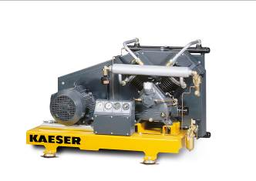
The versatile boosters can deliver compressed air up to 45 bar and are ideal, for example, for the supply of compressed air to PET bottle production plant where economical and energy-efficient, high-pressure air is required.

