M13 and M17

Compact powerhouses

Light, powerful, quiet, versatile and easy to transport – compact machines from the Mobilair M13 and M17 series have always had plenty to offer. When it comes to the latest versions, a wide range of detail enhancements provide even more benefits than ever before.

With a compressed air delivery volume of 1.2 m³ per minute at 7 bar, the M13 portable compressor is the perfect partner for operating air hammers, pneumatic drills, saws, grinders and wrenches, not to mention impact moles and sewer robots. 10- and 13-bar versions of this compact powerhouse are also available. Meanwhile, the 15-bar version of the M17, with a delivery volume of 1 m³/min, is the ideal choice when it comes to trenchless fibre-optic cable laying.

Both of these rotary screw compressors are driven by an air-cooled, 4-cylinder Honda petrol engine via a low-maintenance V-belt drive. A generously sized 20-litre fuel tank ensures sufficient fuel for long daily work shifts, whilst continuous delivery control adjusts the compressed air delivery volume swiftly and precisely to meet actual demand. Such features serve to reduce fuel consumption even further on these already efficient machines. A more powerful battery ensures reliable start-ups and a petrol shut-off valve prevents carburettor overflow during transportation.

Maintenance too is child’s play. The oil separator tank, which serves to ensure a low residual oil content for the compressed air, is equipped with spin-on cartridges, making cartridge changes quick and simplifying service access.

For added sound protection, all models are equipped with a corrosion-resistant sound enclosure constructed from rotomoulded polyethylene (PE). In addition to the standard stylish yellow paint finish, numerous special colours are also available.

For applications in enclosed spaces, on construction sites or in workshops, an emissions-free E-version featuring a 3-phase electric motor is available.

Even very small loading areas can accommodate these compact compressors; they can easily fit inside a closed van, on the loading bed of an HGV or in a pick-up, leaving the trailer coupling free for other transport purposes.

Where specific applications require cool and condensate-free – or even technically oil-free – compressed air, the M13 and M17 can additionally be equipped with an external compressed air aftercooler, optionally available with a microfilter combination. Installed on a support frame, it features fixed connection lines for compressed air, condensate return and the necessary electricity (12 V, supplied by the compressor) to power the aftercooler fan. Accumulating condensate is evaporated by the hot exhaust gases from the engine, or in the case of electric versions, collected in a designated canister.

When it comes to manoeuvrability, the M13 and M17 are exceptionally user-friendly. A long push bar, wheels fitted with pneumatic tyres, four convenient hand grips and a retractable lifting eye guarantee simple transportation to the construction site. Thanks to the wide opening angle of the sound enclosure, all maintenance parts are easily accessible.
Approved for publication, copy appreciated

Image:

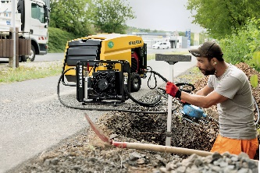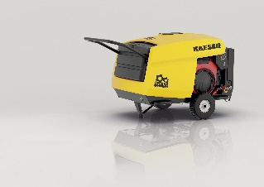

Small but powerful: the M13 and M17 provide compressed air for a multitude of possible applications.

