Sigma Air Service – Comprehensive maintenance and servicing
As a key source of energy, compressed air in manufacturing industries should be available at all times in the correct quantity and at the required quality and pressure. Additional factors such as production-cost reduction and process streamlining also have to be taken into consideration in order maintain a company’s competitive edge. These goals can be achieved only through comprehensive cost transparency and by adopting a holistic approach to air system maintenance and servicing.

Kaeser’s Sigma Air Service is therefore designed to keep compressed air systems operating at the peak of their performance. Experienced system technicians trained in electrics, mechanics, compressed air treatment and system control & management, ensure that every aspect of the customer’s compressed air system is meticulously serviced and maintained. Kaeser plans an individual service and maintenance schedule that is specifically tailored to suit the size and duty cycle of each compressed air system. Supported by specialised online tools to determine optimal service intervals, this planning process helps to enhance compressed air availability, improves system reliability and reduces compressed air costs.
Up to 30 percent reduction in energy costs
Depending on the compressed air installation’s duty cycle, energy costs may account for up to 90 percent of the total costs for compressed air production. It is therefore advisable for a service technician to closely inspect the entire system, and not just individual components, at least once a year. Sigma Air Service has consequently proven to help reduce energy consumption in countless compressed air installations by up to 30 percent
Safety a priority
An optimised compressed air installation is only one of several elements required to ensure that a company has a safe and reliable source of energy. For example, it is essential that all industrial safety and accident prevention regulations are automatically implemented and appropriately documented at all times. Similar to aeroplane maintenance, Kaeser service technicians use checklists and defined consumable-component kits to follow product- and time-specific work schedules.
Amongst many other aspects, this holistic approach to comprehensive system servicing and maintenance focuses on: optimisation of cut-in/ cut-out pressure, system control type, timers and communication of the Sigma Air Manager with the compressors in the installation. In addition, the service technicians carefully document all work and safety inspections carried out on the system.
As a result, the system operator is not only assured of optimised system operation and compressed air availability, but also has the peace of mind in knowing that all work is implemented in accordance with applicable regulations. Sigma Air Service ensures total compliance with compressed air system legislation and provides verification accordingly, whilst ‘manufacturer updates’ keep the system up to date with the latest advances in technology. Furthermore, Sigma Air Service guarantees exclusive use of genuine Kaeser parts, which allow significantly longer component service life and also enable the user to fully benefit from extended service intervals.
Environmentally aware service from a single source
Sigma Air Service enables compressed air users to entrust the complete servicing and maintenance of their compressed air supply system to a team of dedicated experts. The advantages speak for themselves, as users profit from optimised compressed air availability, reduced energy costs and even possible financial benefits from the state. Moreover, lower energy consumption helps to combat climate change through reduced carbon emissions and also helps to safeguard the environment both today and in the future.
Sigma Air Service allows compressed air system users to concentrate on their core business and more effectively use the skills of the personnel formerly required for maintenance to boost company success.

File: l-sigma-air-service-en
4.059 Keystrokes − Free for publication, Copy appreciated

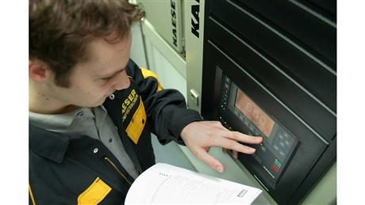
Sigma Air Service not only ensures maximum compressed air availability and outstanding system reliability, but also enables significant cost-savings.

