Kaeser Contain-Air
Ready for immediate duty
Imagine a complete compressed air station housed in a standard shipping container: a quiet, efficient and compact mobile unit ready to reliably supply oil-free compressed air anywhere. Contain-Air solutions from Kaeser are the answer.
The Kaeser Contain-Air is the perfect choice for any application requiring premium quality compressed air, including demanding pharmaceutical or food & beverage industry applications. This compact compressed air station can be deployed at short notice as a temporary source of oil-free compressed air for any production system – and there’s no need to worry about logistics since its standard container dimensions guarantee rapid and straightforward transport. The container houses a durable, air-cooled, oil-free compression rotary screw compressor with the integrated i.HOC rotation dryer, a sophisticated desiccant dryer. This powerful combination not only saves space, but also offers two significant technical advantages:
- The innovative i.HOC drying technology completely prevents condensate formation – either in liquid or ice form, in the winter – in the compressed air line downstream from the container. Unlike other systems on the market, this makes an additional dryer module superfluous.
- Since oil-free compression in combination with i.HOC drying achieves pressure dew points to -30°C, the compressed air can also be used for sensitive production processes.
The easy-to-operate Quick Connect connector panel for pipes and cables enables trouble-free setup at virtually any location and assures rapid Contain-Air system availability in the event of an operational emergency. Even dense urban environments or adjacent office or residential areas pose no obstacle thanks to the clever silencing system. Equipped with insulation and even its own heating system, Kaeser Contain-Air solutions operate reliably in virtually any environment, no matter what the temperature or weather conditions.
Kaeser’s triple certification as per ISO 9001, ISO 14001 and OHSAS 18001 ensures that Kaeser Contain-Air solutions sustainably meet the most stringent requirements of the food & beverage industry when it comes to resource-conserving production, product and process reliability, as well as quality.

File: a-contain-air-en
2.277 Keystrokes − Approved for publication, copy appreciated
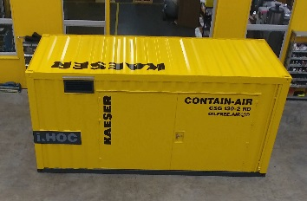
Reliable oil-free compressed air in a compact, durable and mobile package: Kaeser Contain-Air solutions offer a rapid and reliable supply of quality compressed air.

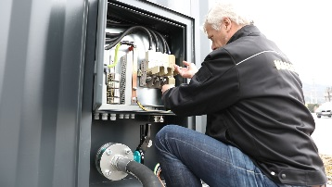
The user-friendly Quick Connect connector panel for pipes and cables enables rapid system setup virtually anywhere.

