Kaeser's new heatless regenerated desiccant air dryer

Achieve low dew points down to
-70 °C reliably and efficiently
Certain areas of compressed air application require extremely dry air, i.e. a very low dew point. Among these are, for example, control air or process air applications in the beverage, food, chemical and pharmaceutical industries; others are applications in areas subject to frost. Air dryers that can satisfy such high demands have to be extremely reliable and need to function as economically and efficiently as possible. Kaeser Kompressoren’s new DC 12 to DC 133 range of heatless regenerated dryers uses the very latest technology to provide outstanding performance and efficiency.

These new models cover airflow rates ranging from of 1.2 to 13.3 m³/min and are supplied ready for use with upstream and downstream filtration. Optimal sizing and intelligent design enables these packages to reliably achieve very low dew points to - 70°C even under extreme operational conditions. The generous volume of high grade "Sigma Dry" desiccant, which saturates only in part during initial loading, helps to achieve these very low dew points. So even though the desiccant is used for longer than average periods of time, only minimal quantities of purge air are needed for regeneration. This not only reduces service costs, but also enables considerable energy savings.

Depending on requirements, two energy-saving controllers are available: At the touch

2/2

of a button the basic version, Eco Control Basic, allows flexible matching of the regeneration period to varying load conditions. This makes for additional purge air savings.

Under conditions of variable airflow, pressure or temperature, Eco Control, a load- proportional controller, is recommended. This controller automatically adapts loading and regeneration periods to demand, contributing considerably to savings in energy costs. With Eco Control and its patented trend recognition dew point regulation, the desiccant chambers are not switched to the regeneration phase until the desiccant has been used to its maximum extent. This can extend the active drying phase by up to 30 minutes, saving a corresponding amount of purge air. In addition and in contrast to conventional methods, an expensive and maintenance intensive dew point measuring device is no longer needed.

In applications where the load phases are often interrupted, Kaeser has on offer dryers with intermittent operation. In these dryers the ongoing regeneration phase is constantly fed with air from an air receiver downstream until regeneration is finished. This means that a fully regenerated chamber is always available when drying starts again. In this way, extreme dew points caused by high desiccant loading are avoided. The control and display panel with its easily understood human interface and graphically clear mimic diagram provides evidence of the very high user-friendliness of the dryer. In addition, these DC dryers can be integrated into master control systems such as Sigma Air Manager, allowing monitoring of all functions.

File: d-dc-en
3.083 Keystrokes − Free for publication, Copy appreciated

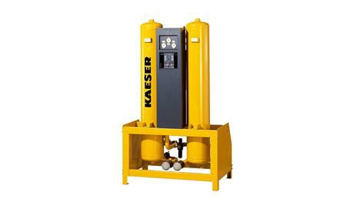

These new heatless regenerated air dryers in the range DC 12 to DC 133 achieve extremely low dew points just as reliably as they are efficient.

