The new “Mobilair 250” portable compressor from Kaeser
Compact, powerful, efficient
Kaeser Kompressoren is proud to introduce the latest iteration of its popular “Mobilair 250” portable compressor, which takes its place alongside the most powerful models in the Mobilair range. Originally setting the trend as the first low-emission portable compressor with a IIIB engine and SCR exhaust after-treatment, this versatile model is completely up to date and already complies with the stringent COM IV (EC) emissions standard. What hasn't changed is the SCR technology of the new Mercedes Benz engine, the impressive air delivery, the compact body and user-friendly operation.
The “Mobilair 250” offers far more than impressive free air delivery of 23.5 m³/min at 10 bar and 21 m³/min at 12 bar, however. Its newly developed rotary screw airend featuring energy-saving "Sigma Profile" rotors and a flow-optimised housing ensure outstanding performance. Designed with maximum manoeuvrability in mind, the Mobilair 250 is also exceptionally compact and lightweight. The standard version, for example, weighs in at less than 3.5 tonnes, which means that it is suitable for use with towing vehicles and is available with a favourably priced chassis equipped with a run-on brake. Alternative stationary versions or chassis models with a compressed air brake system and ABS are also available.
As before, the dependable cold start feature and compressor operation is performed via the three buttons on the SIGMA CONTROL MOBIL controller. This simple yet highly effective controller allows operational data to be viewed at a glance and shows the countdown to the next scheduled maintenance appointment. If required, these data may also be evaluated and transmitted in real-time to the MOBILAIR Fleet Management tool, together with the compressor's location.
Additional air treatment systems provide cool, dry, technically oil-free air of various classes to meet the special demands of e.g. concrete repair in accordance with applicable regulations.
File: c-m250-en
2.033 Keystrokes − Free for publication, Copy appreciated

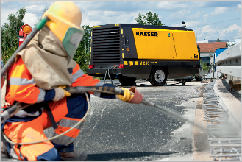
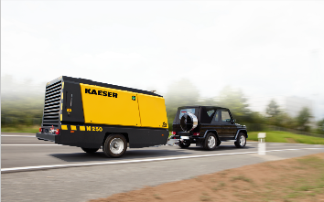
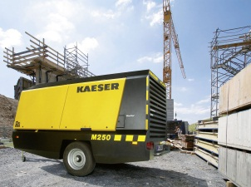

Caption:

The “Mobilair 250” provides an impressive free air delivery of 23.5 m³/min at 10 bar. The standard version weighs in at less than 3.5 tonnes and is already compliant with the COM IV European emissions standard.

Kaeser photo – free for publication

