Sparkling innovation
Kaeser helps to decorate the royal Christmas tree
As the lights were illuminated on this year’s Christmas tree at Windsor Castle, they sparkled in some very special baubles – they are hand blown and adorned with various emblems, the stamps for which come from Kaeser.

Coburg, the home of Kaeser, and the English royal family share a long and storied history together. Prince Albert, Queen Victoria’s husband, came from the House of Saxe-Coburg and Gotha and grew up in the picturesque Franconian city. It was he, in 1848, who brought the first Christmas tree to the English royal household and introduced the tradition he knew so well from his hometown, which would later be adopted throughout the kingdom.

It was this year that Prince Hubertus, the current hereditary Prince of Saxe-Coburg and Gotha, had the idea of presenting Queen Elizabeth II with a Christmas tree as a 90th birthday gift. Coburg and the bordering region of south Thuringia are renowned for their Christmas products. The celebrated fir trees grow in the Franconian Forest and south Thuringia has produced unique hand blown glass Christmas tree decorations for centuries.

It is no surprise, therefore, that there’s also something special about the baubles on the royal Christmas tree. All of the approximately 2000 baubles are hand blown and are partially adorned with one of various emblems which required specialised stamps in order for them be embossed into the baubles. These were produced in the Kaeser training centre. As the Training Manager, Rüdiger Hopf, reminisces “When the request came in, it presented a jolly and interesting challenge.” The reason being that whilst baubles are round, drawings or graphics are typically flat. In addition, despite the round shape, the embossing had to have the same depth at all points. Furthermore, no templates or specifications relating to the motifs were available that could have been used in a CNC machine. All emblems therefore had to be “drawn by hand”. The complexity of making the request a reality was no easy task, particularly since time was of the essence.

However, Nina Bortenlänger, a trainee in technical product design, quickly mastered the graphics challenge, Matthias Gähde, a trainee cutting machine operator, then produced the stamp blanks and the colleagues in the jig department then patiently milled the stamp profiles with micron precision.

Because the work had to be so precise, five hours were needed to machine each emblem. The project required about a week of work and, it has to be said, put a smile on everybody’s face. As Nina Bortenlänger explains, “It was really cool to know who you’re doing it for”. The effort also didn’t go unnoticed elsewhere. The glass blowers in Lauscha were impressed by the exceptionally high quality of the stamps as they produced the baubles embossed with the emblems. It is also worth noting that one of the embossed baubles will be presented personally to the royal family as a gift and, after Christmas, will presumably find a home in a museum.

The tree officially started on its journey from Coburg to Windsor Castle on the 12th of November. The official lighting ceremony for the 13-metre tall fir tree then took place in the square in front of Windsor Castle on the 19th of November. The Queen requested that it take its place there, as the Royal Family will spend the Christmas holidays in Windsor and will be able to cast an admiring gaze upon the majestic fir tree and its glinting baubles from Coburg. The tree also proved to be a big hit with the many visitors to Windsor, as well as with the town’s inhabitants, and will continue to bring joy to all there as a festive gift from Coburg until the 6th of January.

File: p-x-mas-Eng
Images:
Nina Bortenlänger is a trainee in technical product design and was tasked with stamp design for the baubles.
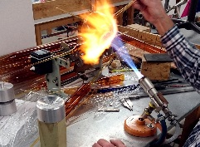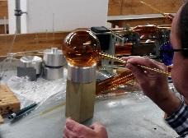
In order to apply the emblem, the hand blown baubles from Lauscha were pushed gently onto the stamp whilst still hot and were then re-blown.
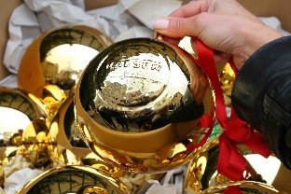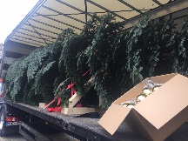
Upon the departure of the tree and baubles from Coburg to Windsor, which was marked by, amongst others, Prince Hubertus (the hereditary Prince of Saxe-Coburg and Gotha) and the Mayor of Coburg, a bauble bearing the Kaeser logo was also packed for the journey.

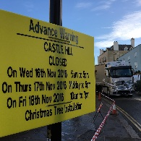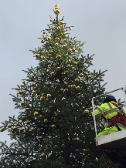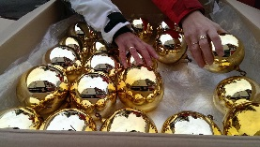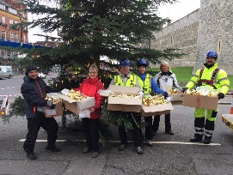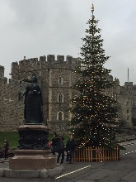
The street was closed while the tree was decorated in Windsor.
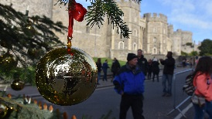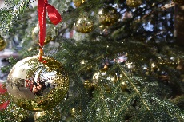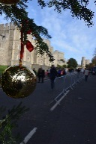
The resulting baubles, here embossed with the Kaeser logo, adorning the Christmas tree.
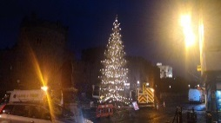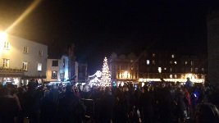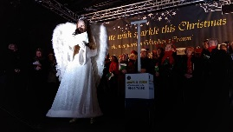
The tree shimmers with glistening light in Windsor. Thousands attended the official lighting ceremony in front of Windsor Castle with the Coburg “Christkind”.
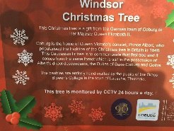
Tags on the tree explain its origins and background.
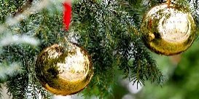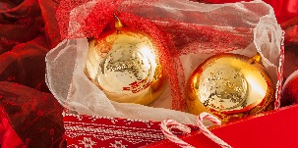
Merry Christmas!

