Rotary blowers with aftercooler: The DB 166 C and DB 236 C
Clever Design for Energy and Cost Savings
With the motto “Intelligence inside”, Kaeser Kompressoren presents its generation of high efficiency rotary blowers. In combination with an efficient aftercooler, the DB 166 C and the DB 236 C not only provide significant energy savings, but also help to reduce overall costs.
In view of continuously soaring prices for industrial energy in recent years, the issue of how to save energy has become a key focus for discussion. An important factor to consider therefore is that the efficiency of a machine, or system, is dictated by its total service life costs rather than just by how much energy it consumes. It was with this knowledge in mind that Kaeser set about developing its latest generation of rotary blowers. The resulting DB 166 C and DB 236 C models are consequently based on inherently intelligent design. System operators not only benefit from the significant energy and operational cost savings that these innovative rotary blower systems have to offer, but are also able to take advantage of considerable savings for installation, planning, commissioning and certification. Covering air deliveries from 10 to 25 m³/min for pressures up to 1000 mbar (g), or 500 mbar (vacuum), the DB blowers also provide exceptional reliability and availability.
Moreover, the addition of an air-cooled aftercooler (ACA) provides significant advantages for temperature-sensitive applications: Specifically designed for use with rotary blowers, ACAs are able to reduce blowing air temperature from 150°C to 10°C above ambient without the complication and expense associated with water-cooled systems. Furthermore, they ensure maximum air usage with minimal pressure loss, as they were specially developed to cope with the large volumes of air generated by rotary blower operation.
The optimised Omega Profile blower rotors and a specially designed block casing ensure maximum delivery volumes and low energy consumption. Performance is further aided by energy-saving IE3 drive motors and high efficiency transmission.
The integrated controller Sigma Control 2 is able to precisely match blower performance to meet demand, is exceptionally user-friendly, monitors all operational parameters and uses a detection system to alert users to maintenance and alarm messages. A master control system can also be easily connected if needed - for example the Sigma Air Manager. Performance and dependability are further enhanced by Kaeser’s clever cooling system, as the blower intake air and motor cooling air are drawn in separately from the ambient surroundings.
The blowers are delivered ready for operation including all sensors, star-delta starter and / or frequency converter (for flexible speed control). They can also be supplied without switchgear / sensors as required. The complete system packages are CE and EMC certified, which means less work for both the operator and system provider when it comes to planning, installation, certification, documentation and commissioning. All equipment is mounted on a compact frame, which means that these systems require even less space than their predecessors. Furthermore, drive motors ranging in power from 7.5 to 45 kW can be installed according to requirement.
Last, but not least, highly effective sound and pulsation damping features ensure quiet operation, whilst safety guards for the fan and drive motor provide operator protection in accordance with all applicable machine regulations.
Free for publication, Copy appreciated

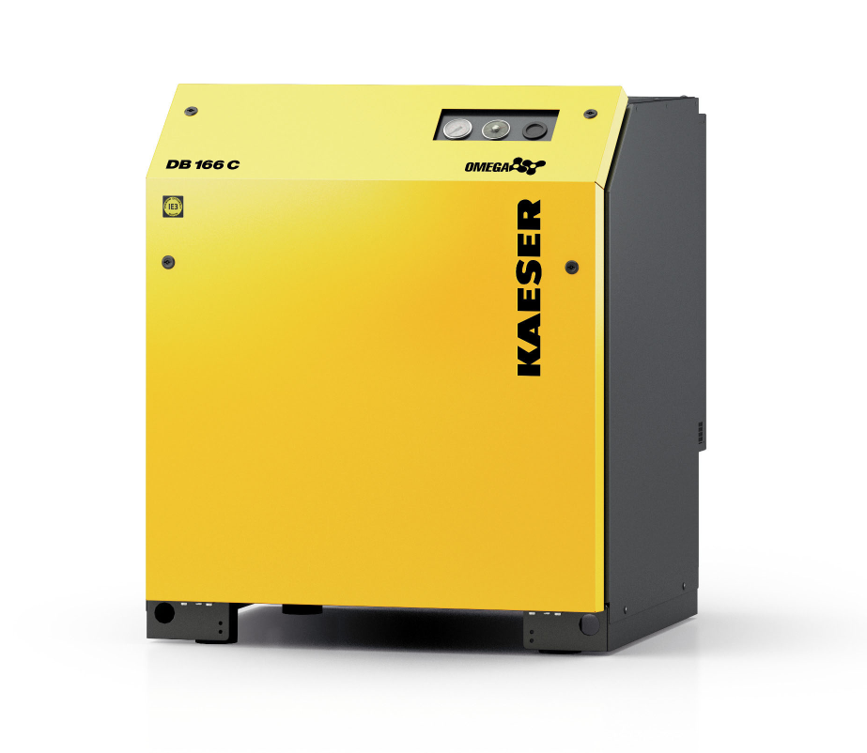
The DB 166 C and DB 236 C rotary blowers ensure exceptional energy efficiency and dependable performance.

