i.Comp 8 and 9 Tower T reciprocating compressor
Premium quality for trades and workshop applications
Anyone looking for a super-quiet, efficient and cost-effective supply of quality compressed air for their workshop requires a user-oriented solution. With the space-saving i.Comp 8 and 9 Tower T, Kaeser Kompressoren is proud to introduce a completely new compressed air supply concept that has been specifically developed with this field of use in mind.
These units are powerful, compact, easy to maintain, efficient and much more. At the heart of the i.Comp family is a drive concept, which provides a multitude of advantages.
The drive delivers the necessary power to cover the required compressed air demand with infinitely variable control. Needless to say, the reciprocating compressor itself is made in Germany and is manufactured to the highest industrial standards for which Kaeser is world renowned.
Moreover, i.Comp family reciprocating compressors are able to operate with 100 percent duty cycles. Intelligent solutions ensure exceptional filling performance and, as a result, outstanding efficiency.
With a volumetric flow rate to 580 l / min, the i.Comp Towers T can be used for a wide range of workshop and trades applications and assure a constant pressure of up to 11 bar with absolute operational reliability.
Made from roto-moulded polyethylene to enable optimum corrosion- and impact-resistance, the attractive sound enclosure not only hides an advanced all-in-one compressed air station comprising a compressor and a refrigeration dryer, but also keeps sound levels to a minimum and helps retain system value.
Kaeser’s field-proven Sigma Control 2 controller allows infinitely variable pressure preselection, as well as connection to a master controller such as the Sigma Air Manager 4.0.
Since i.Comp Tower systems deliver oil-free compressed air, no oil enters the compressed air supply itself. This in turn eliminates the potential for accumulation of oil-contaminated condensate that would otherwise have to be carefully disposed of. In addition, there is no need for oil changes or oil inspection, which of course further reduces overall service costs.
i.Comp Tower systems are the perfect choice for workshop and trades environments, such as in car repair shops, where a dependable supply of quality compressed air is required.
Released for publication, copy appreciated
Image:
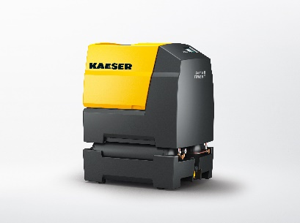

“Compressed air for the workshop”: The stationary Tower T-version of the variable speed and powerful i.Comp workshop compressor provides a dependable supply of quality compressed air for workshop business environments.

