Refrigeration dryers
Reliable and exceptionally compact
With premium quality industrial design, the Kryosec refrigeration dryers from Kaeser Kompressoren deliver dependable drying performance in ambient temperatures up to +50 degrees Celsius – yet are highly efficient and exceptionally compact.
The Kryosec series compressed air dryers from Kaeser Kompressoren provide dependable drying with minimal pressure differential even under the toughest of operating conditions for compressed air flow rates from 0.35 to 4.5 m³/min. Their impressive performance is made possible not only through generously dimensioned heat exchanger and refrigerant liquefaction surfaces, but also by dedicated cooling air flow. These features, combined with low-maintenance design, ensure highly efficient operation.
All models meet applicable machinery safety requirements (EN 60204-1), including a lockable on / off switch and an integrated power supply isolating device. Their high quality construction, compact design and exceptional reliability make them ideal for localised installation on production and processing machines requiring compressed air treated to exacting quality standards. Moreover, with minimal space requirement and wall-mounting capability, Kryosec dryers are impressively versatile. The dryers feature sustainable S-513A refrigerant.
Approved for publication, copy appreciated
Images:
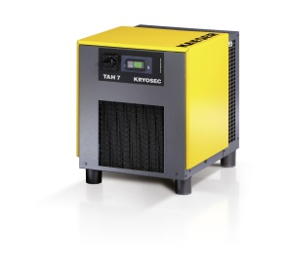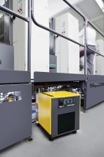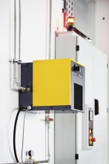
Compact and dependable with high-performance: the Kryosec series dryers ensure reliable compressed air drying even under the toughest of operating conditions.

