Aquamat i.CF
The first intelligent oil-water separator
With the intelligent Aquamat i.CF, Kaeser Kompressoren has redefined condensate treatment. Available for delivery volumes up to 90 m³/min, this new oil-water separator now comes equipped for the first time with the Aquamat Control internal controller, which undertakes active management of the process whilst simplifying maintenance planning and making service work cleaner.
Wherever compressed air is generated, condensate always forms as a by-product. Before this condensate can be disposed of as wastewater, the oil contained within it must first be separated. Conventional, passive oil-water separators work according to the principle of gravity: accumulating condensate trickles through a filter, which then absorbs the oil. Now, the Aquamat i.CF has completely redefined condensate treatment, by actively and intelligently ensuring maximum process and functional dependability.
Dependable, resource-friendly operation
The internal Aquamat Control controller is completely new. It operates by monitoring the condensate level in the oil-water separator; when the maximum level is reached, the condensate is forced through the filter cartridges by light bursts of compressed air. This has the advantage of using the absorption capacity of the cartridges much more effectively. The result is reliable, resource-friendly operation of the Aquamat i.CF, even when operational demands are high. In the unlikely event that a problem arises, the controller recognises it and issues a notification.
This active mode of operation permits – for the first time – the remaining service life of the filter cartridges to be determined, dependent on load. The network-capable Aquamat Control controller not only facilitates maintenance planning for the oil-water separator, it also guides the operator through the necessary work steps.
A further intelligent design feature is that, thanks to pressurisation of the cartridges, they are already empty when the time comes to replace them, making them much lighter to handle.
The overall design of the Aquamat i.CF sets new standards when it comes to hygiene. No contact with the condensate is necessary when changing the cartridges and the whole procedure is contaminant-free, thereby protecting both the environment and service personnel.
Dependable oil-water separation for delivery volumes up to 90 m³/min
The Aquamat i.CF is available in five new model variants for compressors with delivery volumes from 8 to 90 m³/min. For added practicality, all models use cartridges of the same size. This considerably simplifies spare parts stocking and supply, thereby saving time and money.
The different capacities of the five model variants are achieved by connecting multiple cartridges in parallel; this modular design concept enables simple, retrospective adjustment of the respective capacity.
The Aquamat i.CF is certified and approved by the Berlin Institute for Construction Technology for state-of-the-art treatment of compressor condensates containing mineral and synthetic oils. For operators, this provides the highest possible level of technical and legal security.
Free for publication, Copy appreciated

Image:
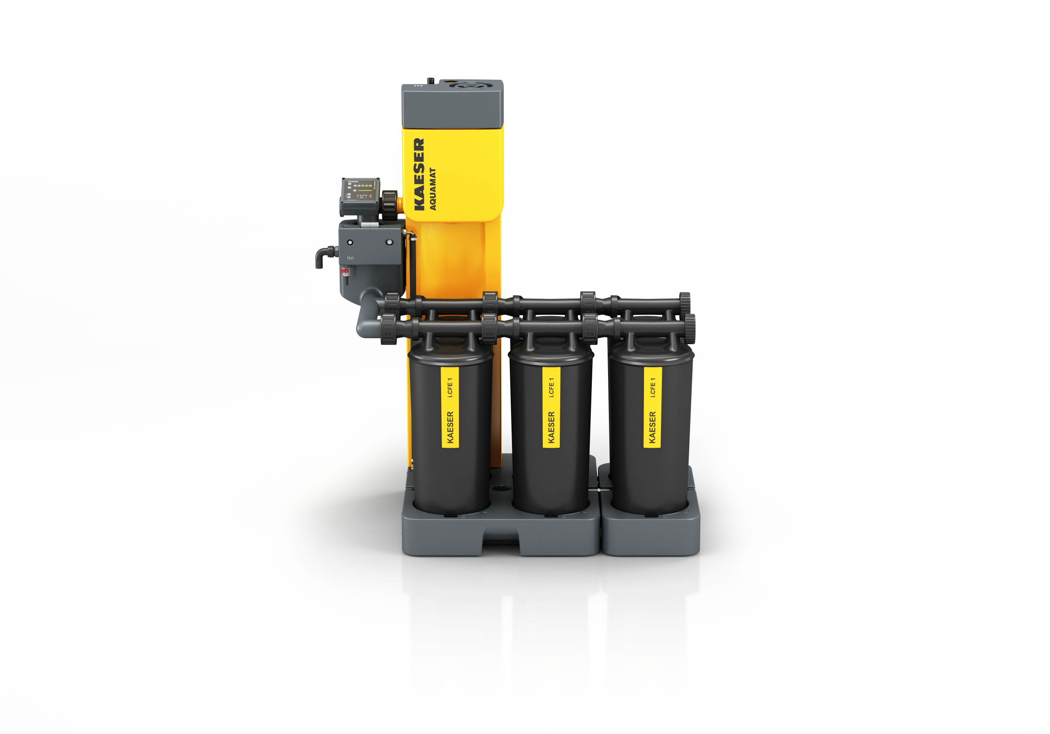
The active, intelligent Aquamat i.CF – clean, safe and modular.

