Chancellor visits Kaeser
Merkel praises Smart Air
As part of her tour marking the opening of this year’s Hannover Messe, German Chancellor Angela Merkel and Polish Prime Minister Beata Szydlo paid a visit to Kaeser Kompressoren’s trade fair stand. Naturally, Kaeser was delighted to welcome Chancellor Merkel and Prime Minister Szydlo. For her part, the Chancellor was enthusiastic about the power of innovation demonstrated by the Coburg-based compressed air system provider.
Hanover/Coburg – German Chancellor Angela Merkel praised the Industrie 4.0 products and services offered by Kaeser Kompressoren as “very nice” whilst Thomas Kaeser, Chairman of the Board at Kaeser Kompressoren, explained these to her in just a few minutes. In her speech opening this year’s Hannover Messe on Sunday, the Chancellor had expressed concern that although there are currently many concepts related to Industrie 4.0, at this point relatively few concrete products and services are actually available. Thomas Kaeser emphasized that Kaeser is different in this regard, mentioning how as a compressed air system provider, Kaeser already offers innovative Industrie 4.0 products and services, and is showcasing them at Hannover Messe. Merkel showed great interest in the company’s background and history, asking about the company’s size and number of employees, and praising the family company.
In conclusion and as a token of thanks, the Kaeser Board presented the Chancellor with a model of a compressor, which she then wanted to “have explained” by her staff.
When it comes to keeping production rolling, industry requires compressed air just as much as electrical power: it’s simply indispensable and has to be available, otherwise production grinds to a halt. It is therefore vital to remain abreast of current developments in compressed air production technology – especially when it comes to solutions for enhancing the reliability and maximising the cost-effectiveness of the compressed air supply. And thanks to its latest digitisation strategy, this is precisely what Kaeser does. Thomas Kaeser explained to the two top-level politicians just how Kaeser does it. The company’s “Smart Air” concept encompasses innovative, networked compressors with “digital twins” in the form of intelligent controllers, real-time data transfer and monitoring, as well as valuable access to Kaeser’s world of expertise. All of these recent developments enable Kaeser to track the “health status” of a compressed air station at all times, which means the company can initiate predictive maintenance before a problem occurs. Moreover, digital system management ensures optimised compressed air costs and sufficient compressed air supply at all times.
File: pm-merkel hmi.en
2710 keystrokes − Approved for publication, copy appreciated
Images:
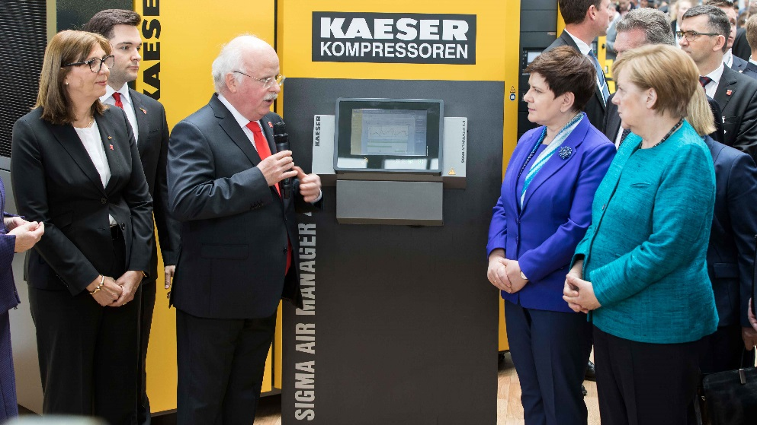
Right to left: German Chancellor Angela Merkel and the Prime Minister of Poland, Beata Szydlo, listen as Thomas Kaeser, Chairman of the Board at Kaeser Kompressoren, presents the latest innovations in the field of compressed air technology (left of Thomas Kaeser are Alexander Jan Kaeser and Tina-Maria Vlantoussi-Kaeser).
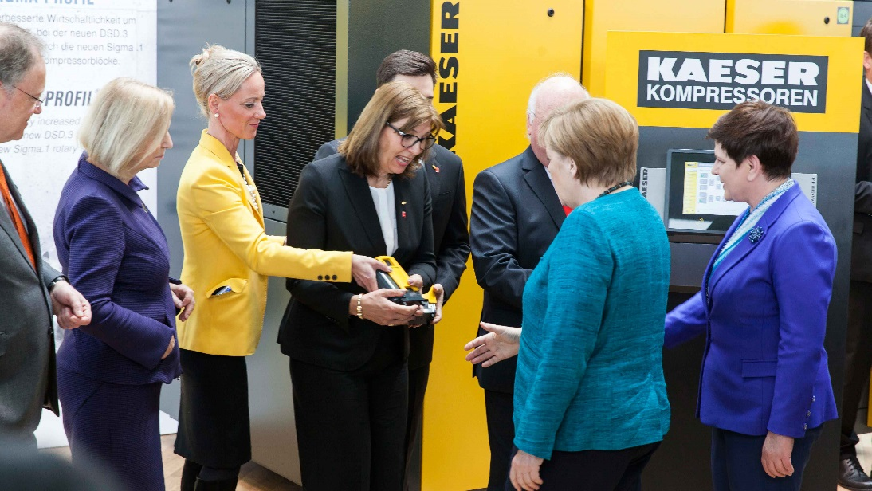
In conclusion, Tina-Maria Vlantoussi-Kaeser presented a model of a compressor to Chancellor Merkel, which she “wanted to have explained.”

