The "Mobilair 50" portable compressor with PE enclosure
A Clear Class Leader
The "Mobilair 50" portable compressor from Kaeser Kompressoren is a machine of many strengths: Delivering enough compressed air power for three breakers, or one ‘heavy duty’ tool, this 5 m³ class compressor is exceptionally lightweight and combines outstanding flexibility with environmentally-friendly operation. Moreover, it uses trusted technology to ensure unrivalled dependability and features a highly durable, double-skinned polyethylene sound enclosure to provide maximum protection from even the toughest of conditions.
One of the first things that strikes you when looking at the "Mobilair 50" is its sleek design: The corrosion- and scratch-resistant polyethylene enclosure, which features integrated wheelhouses, creates the unit’s dynamic look and discreetly hides what lies beneath: impressive performance, energy efficiency and user/environmentally-friendly operation.
With a free air delivery of 5 m³/min at 7 bar, the “Mobilair 50” is powered by a proven, water-cooled, four-cylinder turbo-diesel engine, which directly drives the flow-optimised “Sigma Profile” airend. Direct drive eliminates the transmission losses associated with other systems, consequently providing more air for less fuel. The “Mobilair 50” is therefore the perfect choice for simultaneously powering up to three breakers and is equally suited to impact borer applications.
Almost in contradiction to its exceptional performance, the "Mobilair 50" is surprisingly lightweight and has an operational weight of less than 750 kg, making this unit one of the most manoeuvrable compressors in its class. This aspect also has two further advantages for the European market: Firstly, new drivers do not require an additional towing licence to transport the "Mobilair 50" and, secondly, the unit can be towed without having to be equipped with an overrun brake. Moreover, the low weight means greater manageability when manoeuvring or transporting the unit.
Of course, these advantages also apply where the efficient compressed air aftercooler is selected as an option. Fitted as standard and improving reliability still further, Kaeser’s Anti-Frost Control is particularly useful at times of the year when ambient temperatures are lower, as it protects air tools against freezing, corrosion and potential damage.
All metallic body components are zinc-primed and powder coated to ensure long-term protection from the elements. Operation is made simple via a single control switch and user-friendly icons, whilst excellent component access greatly simplifies servicing and maintenance tasks. Built to Kaeser’s renowned high quality standards, this versatile compressor is designed to provide many years of dependable service.

2.777 keystrokes − Free for publication, copy appreciated

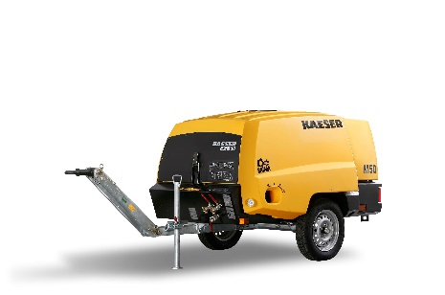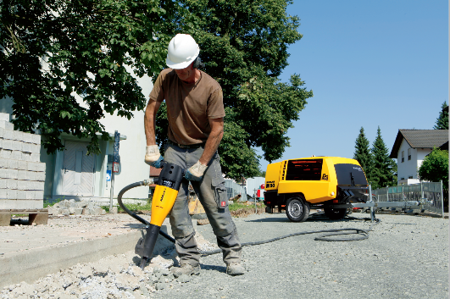

The "Mobilair 50" portable compressor from Kaeser combines sleek design with exceptional performance. The heart of this versatile 5m³ class compressor hides beneath the corrosion- and scratch-resistant PE sound enclosure – now also available with a compressed air aftercooler

Kaeser photo – Free for publication

