1st place award
Kaeser Kompressoren honoured as “Training Ace”
Kaeser Kompressoren takes its place as one of Germany’s elite training enterprises. The Coburg-based compressed air specialist has been bestowed the prestigious “Training Ace” title for its committed endeavours in the field of training.
Coburg/Berlin – The jury of the “Training Ace” competition selected the eleven best training concepts from approximately 200 submissions. The results of the competition were announced at the formal awards ceremony which took place at the Federal Ministry of Economics in Berlin on the 12th of December and Kaeser Kompressoren took first place in the Industry, Trade and Services category and got the gold trophy.
“We are delighted to be honoured with this award. Training at Kaeser Kompressoren is something we greatly value. A strong commitment to training pays long-term dividends, since a solid education provides an excellent foundation for a happy and fulfilled life”, said Thomas Kaeser, Chairman of the Board at Kaeser Kompressoren.
He continued by saying “When we prepare young people well for their professional future, we not only support them, as members of society, to make an important contribution, but also of course benefit ourselves in return. The apprentices of today become the experts of tomorrow”.
This year, 110 young people began their training at Kaeser, of who 21 come from refugee backgrounds and 12 from other countries within Europe. Kaeser currently engages a total of approximately 300 apprentices at its Coburg and Gera sites.
For some 20 years now, the Junior Chamber International Germany association and the Junior Association for Skilled Crafts and Trades, together with the INTER insurance group, has bestowed the “Training Ace” award in the categories of industry, skilled trades and off-the-job, vocational or academic training initiatives.
The aim of the “Training Ace” award is to promote and recognise outstanding commitment to the preparation and training of youth for professional life. The jury places special evaluative focus on the creativity, quality and quantity of the training activities and methods.

File: o-Ausbildungs-Ass_(1. Platz)-en
2,121 keystrokes − Free for publication, Copy appreciated
Images:
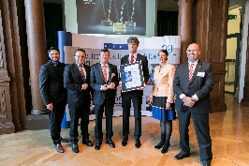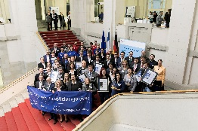
Awards ceremony in Berlin (from left): Marco Jaeger (Handwerksjunioren), Hans-Peter Friedrich (Member of the Geman Bundestag), Dr. Rolf Eberwein (HR manager Kaeser Kompressoren), Rüdiger Hopf (Director of Vocational Training Kaeser Kompressoren), Michaela Partheimüller (Wirtschaftsjunioren), Michael Schillinger (Inter Versicherungsgruppe).
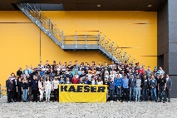
The freshly inaugurated Coburg apprentices who started with Kaeser Kompressoren in September 2016.
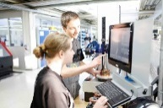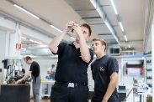
State-of-the-art production methods and classic fundamental knowledge – the trainees at Kaeser Kompressoren learn the entire spectrum through personal experience.

