Kaeser Sigma Network
Join the Kaeser Network
Fast, secure and future-ready! The powerful Ethernet-based Sigma Network developed by Kaeser provides optimised compressed air station monitoring and control. Moreover, it is able to take advantage of the future-oriented benefits that Industry 4.0 has to offer.
Industrial applications place special demands on communication - including machine to machine communication - and this is the basis of Industry 4.0. The technology must not only be durable and easily manageable onsite, but should also be globally compatible, fast and secure and be able to transfer large volumes of data with maximum integrity. In addition, it should ensure the real-time capabilities required by the process. Kaeser Sigma Network meets all of these needs and more…
Secure data
Based on secure Ethernet technology, the future-ready Sigma Network is a local network within the compressed air station that enables optimised integration of a station`s components. Unlike current field-bus solutions, such as Profibus, CAN or similar technologies that operate at relatively slow speeds (max. 12 Mbit/s), Sigma Network has a transfer speed of 100 Mbit/s. The widely accepted TCP/IP protocol standard - also recognised as the Lingua Franca of the Internet – forms the basis for data traffic in the Sigma Network.
The Network uses Kaeser-own MAC addresses and creates a closed and secure network segment in accordance with the recommendations for industrial control systems. A defined transfer node enables secure data exchange with external partners.
Basis for predictive maintenance
Sigma Network, working in perfect harmony with the Sigma Air Manager 4.0 master controller, forms an infrastructure that makes data available for future services, such as predictive maintenance, or energy management. This not only reduces costs, but also increases operational reliability and availability. If needed by the user, operational data from the compressed air station can be securely transferred to the Kaeser Data Centre via a broadband connection. This allows Kaeser experts to perform remote diagnostics and enables predictive and demand-oriented maintenance. Users therefore benefit from maximum supply dependability, as well as lowest possible life-cycle costs, since Kaeser's compressed air specialists are able to adjust the energy characteristics of the compressed air station as required so that the station performs at maximum efficiency at all times.
File: m-sigma network-en
2.467 keystrokes − Free for publication, copy appreciated

Images:
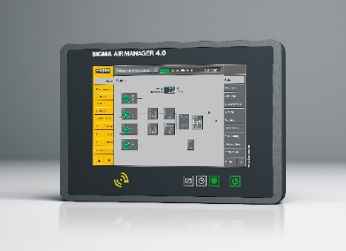

Sigma Network: The powerful Kaeser Sigma Network provides optimal compressed air station monitoring and control and provides advanced Industry 4.0 operational capability.
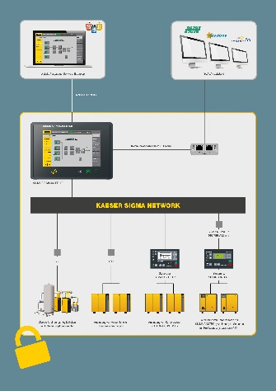

Sigma Network combines optimal integration of compressed air station components with efficient and convenient external access to, and use of, gathered data.

