The optimised "Mobilair 123" portable compressor from Kaeser
Exceptional Efficiency and Performance
The Mobilair 123 portable compressor from Kaeser was designed with maximum performance and versatility in mind. Now available as an optimised version featuring the innovative "Sigma Control Mobile" compressor and engine control system, this quality compressor combines increased air delivery with enhanced fuel efficiency.

Blasting work with various materials, such as sand or dry-ice, concrete cleaning, simultaneous operation of heavy-duty pneumatic breakers, or even temporary replacement of a stationary compressor: These are just some of the Mobilair 123’s many talents. However, this inherently efficient portable compressor now delivers even better performance and efficiency. Kaeser's engineers have been able to increase the free air delivery at 10 bar by approximately 2 % to 10.8 m³/min and by more than 6.5% at 12 bar to 9.7 m³/min; fuel consumption at partial load has also been significantly reduced. The compressor is powered by a four-cylinder Deutz turbo diesel engine with electronically controlled common rail direct injection, which achieves a power output of 88 kW at 2100 rpm. Moreover, the M 123’s highly efficient cooling system has been specially designed to accommodate this impressive performance and the whole unit rests on a robust AlKo chassis that has a load capacity of 2200 kg.

Available with various equipment options, the "Mobilair 123" provides a flexible source of energy for a wide range of construction site needs: For special applications, the "M 123" can be supplied as a skid-mounted version instead of a standard chassis-mounted model. Optional additional equipment includes air treatment systems to provide cool, dry, oil-free air of various classes to meet the special demands of e.g. concrete cleaning as per German ZTV-SIB regulations, or quality fresh air for tunnel construction sites.
"Sigma Control mobile": User-friendly and saves fuel
By precisely matching motor power to actual compressed air demand, the new "Sigma Control Mobile" (SCM) enhances compressed air availability as well as fuel efficiency. Moreover, the electronically controlled air intake valve allows system pressure to be precisely controlled to within 0.1 bar directly from the SCM's display. This not only simplifies operation, but also enhances fuel efficiency by between 5 and 10% compared with conventional pneumatic control when operating at partial load.

Specially tailored for Kaeser "Mobilair" products, the intelligent SCM was built to withstand the toughest of construction site conditions: A sturdy metal cover protects the control panel, screen and input keys of the shock- and vibration-resistant control system. Moreover, the system is shielded against electromagnetic interference as per IP 65 standards and can be used in a temperature range from -20 °C to +70 °C. Amongst its many features, the "Sigma Control Mobile" displays operational data, indicates operational modes, utilises logically structured menus for maximum user-friendliness and enables performance monitoring, as well as remote diagnostics. Further features include engine diagnostics, comprehensive system monitoring and alerts to potential problems and various maintenance messages. 2 wide-opening enclosure doors also allow excellent component accessibility for unrivalled ease of maintenance. Users are therefore able to benefit from all of the advantages that modern compressed air technology has to offer including maximum machine availability and outstanding system performance.

File: c-m123-en
3.588 Keystrokes − Free for publication, Copy appreciated

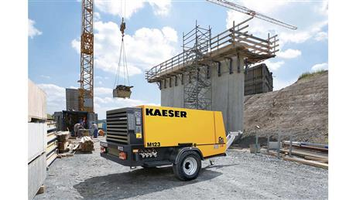

More efficient than ever: The optimised "Mobilair 123" combines a free air delivery of almost 11 m³/min at 10 bar with enhanced fuel efficiency.

