The New ‘Mobilair 100’ Portable Compressor from Kaeser
Exceptional Power and Performance

Modern portable compressors should not only deliver exceptional power and performance, but should also ensure quiet operation and versatility. The new ‘Mobilair 100’ from Kaeser meets all of these needs and is setting the new standard for portable compressors in the 10 m³ class.
With an effective free air delivery of 10.2 m³/min at 7 bar and four compressed air outlets, the new ‘M 100’ from Kaeser Kompressoren’s ‘Mobilair’ range is an asset on any construction site and can truly be described as a portable compressed air powerhouse. Versions with maximum working pressures of 10, 12 and 14 bar are also available, with the latter allowing infinitely variable pressure adjustment down to 5 bar via a manual wheel control.
The ‘Mobilair 100’ features a specially designed energy-saving Sigma profile airend, which is directly driven by a water-cooled, four-cylinder Kubota turbo-diesel engine producing 71.7 kW. The unit’s high performance however is also combined with quiet operation to ensure a sound pressure level (measured as per ISO 3744) of 69 dB (A) and a sound power level of ≤ 99 dB (A) as per 2000/14/EG.
Providing a reliable source of quality compressed air, the Mobilair 100 is designed for use in ambient temperatures ranging from -10 to +50 °C, but is also available as cold-climate version that can be used down to -25 °C. Fitted as standard and improving reliability still further, Kaeser’s Anti-Frost Control is particularly useful at times of the year when ambient temperatures are lower, as it protects air tools against freezing and corrosion. In addition, manual switchover from pressure- free start to full-load operation ensures gentle compressor start-up even under cold conditions.
Every unit is also equipped with a large capacity fuel tank that enables uninterrupted operation during long work shifts and eliminates the need for continuous refuelling. But perhaps the most outstanding characteristic of the ‘Mobilair 100’ is its versatility: The addition of various integrated air treatment components enables production of cooled, dried and technically oil-free air of various classes to meet the special demands of e.g. concrete repair and fresh-air applications. In addition to the standard towing chassis (with inertia brake and fixed or height-adjustable tow bar), the compressor is also available as a skid-mounted version, or with feet.
Moreover, the galvanised compressor bodywork is powder coated to provide long- term protection from the elements, whilst wide-opening gull-wing doors allow excellent component accessibility for unrivalled ease of maintenance. Operation is also made simple via an easy-to-use control panel and user-friendly icons.
As one would expect therefore, the versatile ‘Mobilair 100’ portable compressor is built to Kaeser’s renowned high quality standards and is designed to provide many years of dependable, efficient service.

2.975 Keystrokes − Free for publication, Copy appreciated

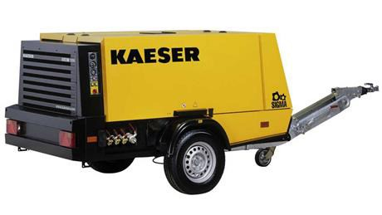
Modern portable compressor with exceptional power and performance: the new ‘Mobilair 100’.

