The new FSD rotary screw compressor series from Kaeser
Reduce Costs with Efficient Air-Cooling
When dealing with consumption of mass volumes of compressed air, not only is air system reliability important, but so too is efficient compressed air production. With free air deliveries up to 57 m³/min, Kaeser’s new space-saving FSD series rotary screw compressors ensure outstanding performance and provide highly efficient, modular compressed air solutions that are specifically designed to meet these requirements. Each unit also features cost-effective air-cooling and Kaeser’s maintenance-free 1:1 direct drive system.

Air-cooling of screw compressors is up to 60 percent cheaper than using water-cooled systems. Kaeser’s new FSD compressor range now enables users to take advantage of these significant savings for drive powers of 250 kW and higher. This is made possible by Kaeser’s highly effective cooling system, which uses an innovative radial fan that draws cool ambient air in through the cooler. The system prevents the cooling air from being pre-warmed and, as a result, optimises the cooling effect to allow trouble-free operation in extreme operating conditions up to + 45 °C.

However, FSD series compressors have many other benefits to offer: They provide the very best in energy efficiency, compact design, quiet operation user-friendliness, ease of maintenance and reliability.

FSD compressors gain their efficiency by using specially developed airends equipped with Kaeser’s world-renowned “Sigma Profile” rotors. In addition, each unit features a high-efficiency IE3-rated motor that turns at only 1490 rpm, which further enhances system service life. The airend and motor are designed to operate at the same low speed and are linked via a 1:1 maintenance-free drive coupling. This feature not only eliminates the transmission losses associated with gear or belt drive, but also considerably reduces energy consumption, maintenance requirement and sound output levels. The cooling system with its unique airflow design and radial fan also plays an important role in ensuring that FSD compressors provide ultra-quiet performance. Although the fan uses significantly less energy than a conventional axial fan, it still has more than four times the reserve thrust of standard designs. This enables connection of exhaust ducting without having to install additional extractor fans. Water-cooled FSD units are also available if required.

The PC-based “Sigma Control 2” internal compressor controller is fitted as standard on all FSD models. This user-friendly controller allows greater energy saving potential, reduces maintenance requirement and increases compressor system reliability and availability. The “Sigma Control 2” also enables direct communication with the “Sigma Air Manager” (SAM) compressor management system, which also uses PC-based technology. The SAM provides seamless interaction between all components (up to 16) in the compressor system and offers complete air cost transparency. In addition, its minimal switching differential minimises equipment idling time, consequently increasing efficiency and enabling highly flexible control.

As the use of variable speed drive has significant advantages for certain applications, an FSD model is available with Kaeser’s Sigma Frequency Control (SFC). Within its wide control range, the SFC-equipped model is able to precisely adjust compressor performance to meet actual demand.

Together with correct planning and the use of perfectly matched compressed air system components, FSD compressors can help achieve considerable energy savings of 30 percent or more compared with conventional compressed air solutions.

File: a-hsd-en
3.684 Keystrokes − Free for publication, Copy appreciated

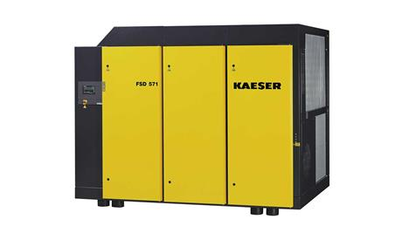

FSD rotary screw compressors now enable high efficiency air-cooling for compressors with drive powers of 250 kW and higher and free air deliveries of up to 57 m³/min. They provide all the advantages of modern modular design to ensure an efficient and reliable source of quality compressed air.

