Sigma Profil with reluctance motor
An unbeatable one-two combination
Responsible use of resources is one of the key factors to which Kaeser Kompressoren owes its success. As a leading compressed air systems provider and a renowned industry trendsetter, Kaeser is proud to present yet another technological milestone. For the first time, the ASD series of variable-speed compressors will be equipped with synchronous reluctance motors – a major advantage due to their considerably lower losses in the crucial partial-load range, compared to asynchronous motors.
With Sigma Profil and innovative drive concepts, Kaeser's ASD series of rotary screw compressors offer flow rates ranging from 3.15 to 5.5 m³/min, delivering outstanding performance and reliability, combined with energy efficiency and space-saving design.
The trendsetting company is now taking another important step – releasing its ASD series of variable-speed rotary screw compressors with a completely new drive technology. The major advantage of this complete solution, which was developed in close partnership with Siemens, is that it delivers efficiency gains of up to ten percent in the partial-load range. This drive principle has been understood for decades. But only now has its implementation in production series motors attained the technical perfection required to benefit users throughout the world.
Variable-speed drive with high system efficiency
With our variable-speed versions (SFC) of the ASD series, we offer customers worldwide an opportunity to embark on a path of minimal energy consumption – and minimal operating costs. This is important because compressed air stations are often constructed on a modular basis: Continuously running compressor systems with IE3 and IE4 motors cover base load demand, whilst additional peak-load compressors respond flexibly to meet extra demand; the system as a whole is controlled and co-ordinated by a SIGMA AIR MANAGER 4.0 master controller to ensure maximum efficiency. With the Siemens synchronous reluctance drive systems, this will be performed with even greater efficiency, particularly in the all-important partial load range.
The new EN 50598 eco-design standard applies not only to the efficiency values of individual drives, as previous legislation did; rather, it represents a shift in regulatory emphasis to overall system efficiency. Consequently, the compliance of variable-speed drive solutions will now be assessed based on their overall system efficiency, and not on the efficiency of their components alone.
Combining the best of synchronous and asynchronous motor technology
This new and innovative range of general-purpose motors combines the advantages of both asynchronous and synchronous motors in a single drive system. On the one hand, no aluminium, copper or expensive rare earth magnets are used in the rotors; instead they are made of electrical steel with a specialised profile and arranged in series – making the drive highly durable and maintenance friendly, the characteristic advantages of asynchronous motors.
On the other hand, the control properties of the new motors are comparable to those of synchronous motors. Because of the special rotor design, reluctance motors deliver high speeds without additional rotor warming due to current flow. The key to this lies in optimised matching of the drive system elements, i.e. the motor and frequency converter. It is the perfectly harmonised interplay between these two components that facilitates maximum energy savings.
Innovative drive system for a sustainable future
The ASD-SFC series has now been equipped for the first time with the innovative synchronous reluctance motor drive system from Siemens. The new drive technology delivers efficiency gains of up to ten percent in the partial-load range, top IES2 classification as per the new EN 50598 efficiency standard, as well as significantly lower energy costs. This translates into average energy cost savings of around 450 euro per year, according to the compressor manufacturer (based on 6,000 operating hours at a rate of 10 cents per kilowatt-hour).
Users therefore not only enjoy maximum flexibility for specific applications and varying environmental conditions, but also with regard to load response. Together with its high efficiency IE4 asynchronous motors, Kaeser has now raised the bar of drive technology efficiency to a new level, exerting environmentally friendly competitive pressure across the market.
File: A-ASD-Reluktanzmotor-en
4,826 characters – Free for publication, Copy appreciated

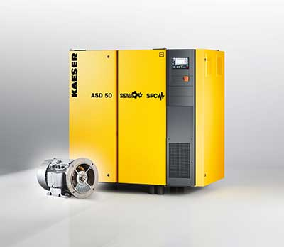

Kaeser’s variable-speed versions of ASD rotary screw compressors are available with a synchronous reluctance drive system from Siemens.

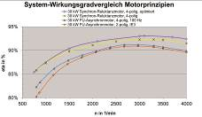
In comparison, the synchronous reluctance motor achieves significantly better efficiency values.

