Compressed air audits highlight savings potential
Reduce Costs, Minimise Emissions
Soaring energy prices and the apparent threat of rapid climate change are putting the industrial business sector under considerable pressure. Currently, the only truly effective remedy to these issues therefore is to enhance system energy efficiency. This is where modern compressed air technology can make a significant difference. For example, a detailed compressed air audit is a highly cost-effective way to highlight areas for potential savings in existing compressed air systems.

Studies¹ have found that compressed air systems in Europe would consume, on average, 33 percent – and in some cases 71 percent – less energy if appropriate optimisation measures were taken. Energy consumption accounts for the vast majority of a compressed air system's operating costs.

The prerequisite for effective system optimisation lies in implementation of a comprehensive compressed air system analysis. Modern computer-aided processes, such as Kaeser's ADA (Air Demand Analysis) technology, are relatively easy to implement and achieve impressive results. The use of data-loggers allows compressed air system performance to be monitored without having to interfere with the air distribution network and air consumption values can be determined via flow measurement. This data is then used to ascertain the efficiency of the individual compressors and to identify 'weak points' within the system as a whole. All necessary data is gathered using data-loggers and is subsequently transferred to a PC, whereupon a system-specific air consumption profile is created. The profile identifies demand fluctuations, idling performance, compressor operation / downtime and also shows allocation of power of each individual compressor in relation to compressed air demand. The data from the air demand analysis is then evaluated with the help of a specialised computer program ('Kaeser Energy Saving System', or 'KESS' for short) to determine the best overall system solution. In addition, KESS is also able to simulate various alternative systems and compares these with the existing compressed air installation. This comparison, together with a calculation of the amortisation period, consequently reveals the scope of the modernisation measures that need to be taken e.g. new configuration, replacement of some / all compressors and /or compressed air treatment components.

The use of an advanced compressed air management system, such as the 'Sigma Air Manager' (SAM), is also recommended to ensure long-term compressed air system efficiency and to keep emissions of greenhouse gases to an absolute minimum. Combining the versatility of a modern industrial PC with well-proven Internet technology, the “Sigma Air Manager” (SAM) is an all-in-one master controller and web server that offers precision co-ordination of the compressors and associated system components within a compressed air installation. Available as an added option for the SAM, “Sigma Air Control plus” is a long-term analysis tool which can be used without the need for additional specialised software via any desktop computer which is equipped with a standard browser and internet access. On-load and off-load status, system pressure, power consumption and compressor duty cycles can all be displayed and evaluated from various aspects for an elapsed period of up to one year. This allows the user to keep a constant eye on compressed air costs and to closely monitor operation of the air system at any time.
1: See Seitz, Anja: Ergebnisanalyse der von KAESER KOMPRESSOREN durchgeführten Air-Audits für die Kampagne Druckluft-effizient. Diplomarbeit Fachhochschule Coburg, Fachbereich Maschinenbau (2004)

File: l-ada-en
3.744 Keystrokes − Free for publication, Copy appreciated

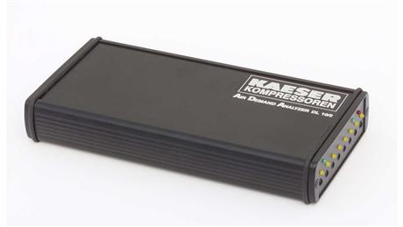
Compressed air audits using modern data-loggers (image) are easy to carry out and provide invaluable information regarding compressed air system efficiency and optimisation potential.

