Mobilair M20
The talented all-rounder
Breaking and demolishing operations, powering impact moles or low-pressure blasters, and much, much more – the potential applications for the M20 portable compressor are many and varied. What’s more, when the optional support frame with aftercooler is added, providing a supply of cool, condensate-free compressed air, the possibilities become virtually endless.
The M20 is proof that powerful does not have to mean large and heavy. With a delivery volume of 2 m³/min at 7 bar, it boasts sufficient power reserves to operate two 18-kilogram breakers, yet weighs in itself at just 460 kg. This it achieves thanks to its sophisticated design, its energy-saving rotary screw airend with the flow-optimised “Sigma Profile”, a loss-saving 1:1 direct drive and, last but by no means least, a water-cooled Kubota three-cylinder diesel engine, which meets the stringent emissions standards of EU Stage V without need of a diesel particulate filter and AdBlue additive.
When cool, condensate-free compressed air is required, an optional compressed air aftercooler is available. Installed on a support frame, it features three fixed connection lines for compressed air, condensate return and the necessary electricity (12 V, supplied by the compressor) to power the aftercooler fan. Rather than being discharged, the condensate accumulated during cooling is retained inside the unit, where it is evaporated by the hot exhaust gases from the engine. The standard-equipped closed floor pan prevents accidental ground contamination.
Furthermore, the M20 is equipped as standard with Anti-Frost Control, which brings important advantages when operating in relatively low temperatures: connected compressed air tools benefit from best possible protection against freezing and corrosion damage, thereby enhancing their dependability and service life.
Manufacturing quality, ease of maintenance and user-friendliness are all exceptional: premium-quality zinc pre-treatment and powder coating of all metal body panels provide long-lasting corrosion protection, whilst all maintenance-relevant components are easily accessible. Operation by means of a single switch is child’s play; what’s more, it is explained clearly by easy-to-read pictograms provided on the enclosure, beneath the instrument panel.
The M20 has style as well as substance. The eye-catching sound enclosure is constructed from rotomoulded polyethylene and features integrated wheel arches. This is not just for show: not only is the unit extremely tough, it also provides exceptional protection from scratches and corrosion, whilst making it abundantly clear precisely what it conceals beneath it – power, efficiency, user-friendliness and eco-friendly operation.
Approved for publication, copy appreciated

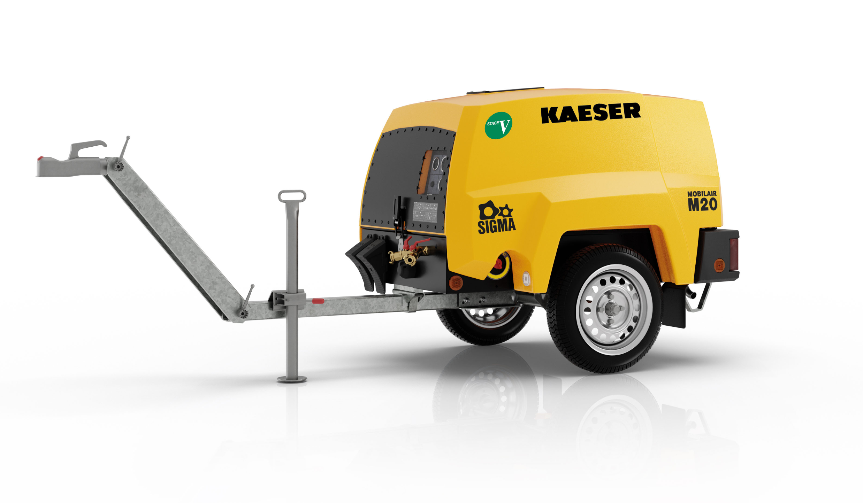

The M20 is the perfect all-rounder for an unlimited number of applications.

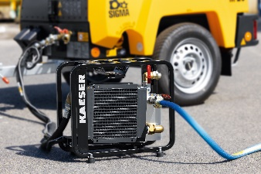

The M20 is capable of delivering cool, condensate-free compressed air thanks to the optional aftercooler.

