Foundation stone ceremony
New space for new ideas
There will no doubt be cheers from many people at Kaeser Kompressoren when the company’s new administration building is complete, as there will be new capacity to relieve the pressure on existing offices where space is currently at a premium. The first stage of this significant investment was marked by the recent foundation stone ceremony.
Representatives from the Coburg-based compressed air specialist and participating construction companies, together with local dignitaries, gathered on Friday the 4th of September, 2015, to immure a time capsule commemorating construction of Kaeser’s new administration building. Amongst other items, the capsule contains current newspapers and a selection of coins.

The need for the new building arose from the fact that various departments had become spread throughout the Kaeser site due to space constraints and because capacity in the existing office areas was becoming increasingly limited. By enabling departments to be closer together and enhancing communication between employees, the new facility will therefore “create new space for new ideas”, Thomas Kaeser explained.

Move-in phase from 2017
The construction phase of the administration building itself is due for completion in late 2016, with the move-in phase prospectively beginning in spring 2017. Once the new building is complete, modernisation of the non-renovated section of the existing building will then begin.

File: p-grundsteinlegung verwaltung-Eng/Sept. 2015
1281 keystrokes − Free for publication, copy appreciated
Images:
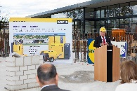
Thomas Kaeser, Chairman of the Managing Board at Kaeser Kompressoren.
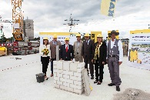
Foundation stone ceremony (from left): Tina-Maria Vlantoussi-Kaeser, Mayor of Coburg Norbert Tessmer, Thomas Kaeser, architect Harald Eichhorn, Mohammad-Reza Shabestari (Kaeser), Deputy Mayor of Coburg Dr. Birgit Weber, Jürgen Dorst (Strobel construction).
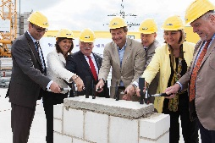
The foundation stone is sealed in place following numerous hammer blows (from left): Mohammad-Reza Shabestari, Tina-Maria Vlantoussi-Kaeser, Thomas Kaeser, architect Harald Eichhorn, Dieter Wolf, Deputy Mayor of Coburg Dr. Birgit Weber, Mayor of Coburg Norbert Tessmer.

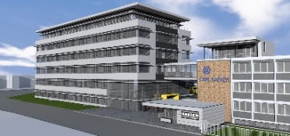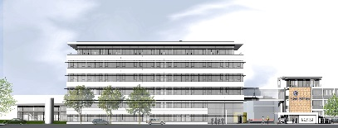
Kaeser Kompressoren’s new administration building will be located to the left of the existing building and will offer lots of new space for employees.

